Nine Point Circle
- Construct a triangle and place points on the midpoints of the three sides. These will be the first three points on the nine-point circle. (Label P1 P2 P3)

- Create a new triangle with these points.

- Now construct the altitudes and place points at the places where the altitudes intersect the sides of the triangle. These three points will be the next three points of the nine-point circle. (Label P4 P5 P6)

- Now only show the parts of the altitudes that go from the vertex to the point of concurrency

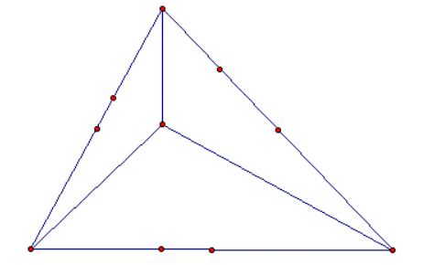

- Now show the midpoints of these altitude portions. They will be the last three points of the nine-point circle. (Label P7 P8 P9)

- To obtain the center of the nine-point circle, circumscribe the new smaller triangle. To do this, find the perpendicular bisector of each side of the new smaller triangle.

Constructing Points of Concurrency
Using Geogebra, construct the centroid, circumcenter, orthocenter, and incenter of a triangle. Using the drag test, make some conjectures about the points.
Centroid - The centroid of a triangle is constructed by taking any given triangle and connecting the midpoints of each leg of the triangle to the opposite vertex. The line segment created by connecting these points is called the median. The centroid is the center of a triangle that can be thought of as the center of mass. It is the balancing point to use if you want to balance a triangle on the tip of a pencil, for example. (Hide all constructions and label this point Ce)
-Find the distance between the midpoint and Ce, and Ce and the vertex of the median. Determine the relationship between parts of each median.

Circumcenter - The circumcenter is the center of the circle such that all three vertices of the triangle are the same distance away from the circumcenter. It is found by finding the midpoint of each leg of the triangle and constructing a line perpendicular to that leg at its midpoint. This is the intersection of perpendicular bisectors of the sides of the triangles. (Hide all constructions and label this point Ci)
- Is the circumcenter ever outside the triangle? Is the circumcenter ever on the triangle?
- What is the distance between the circumcenter and the vertices of a triangle?

Orthocenter - The orthocenter is the center of the triangle created from finding the altitudes of each side. (Hide all constructions and label this point O)
- Is the orthocenter ever outside the triangle? Is the orthocenter ever on the triangle?

Incenter - It is the point forming the origin of a circle inscribed inside the triangle. It is constructed by taking the intersection of the angle bisectors of the three vertices of the triangle. The radius of the circle is obtained by dropping a perpendicular from the incenter to any of the triangle legs. (Hide all constructions and label this point I)
What is the distance between the incenter and the sides of a triangle?

Three of four of these points are collinear. The line they lie on is called the Euler line. Drag the triangle to see which three are.

When all four points are collinear, what kind of triangle do you have?

When all four points are coincident, what kind of triangle do you have?

Make your triangle scalene, then construct a line segments connecting two of the three points on the Euler line and passing through the third. This is the Euler segment. What are the endpoints? What is the point on the Euler segment?

The point on the Euler segment divides it into two parts. Measure the distance between the endpoints of each of these two parts. Look for a relationship between these distances.

